**Date:** 7 Oct 2016

**Description:**

Request to print additional pallet shipping label for each bundled item.

Label printing:

E.g. Bundle item with 3 components item.

1 set of label will contain:

1. Without carton ID (for pallet label)
2. Carton 1 of 3
3. Carton 2 of 3
4. Carton 3 of 3

Pallet Label Carton Label Carton Label Carton Label

2 OF 3

3 OF 3

1 OF3

{No carton ID}

System will print **4 set of labels in total,**

1st and Last set will use for attachment and paste on label clearance form

1 set carton label use to paste on component item

1 set carton label to be discarded

2 copies of pallet shipping label to be pasted on outer pallet (bundled pallet will be shrink wrap or using pallet sleeve)

WMS Changes:

Bundle Master (BOM) setting:

Update configuration “Label Convention” :

Bundle with 2 component cartons:

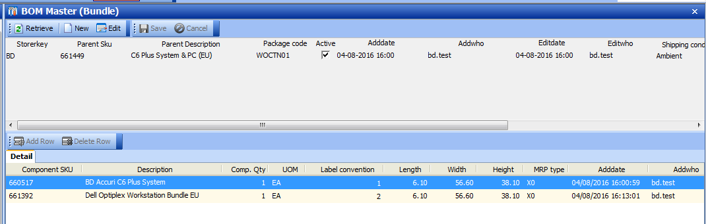

Work order Status Update – Print 1st Label

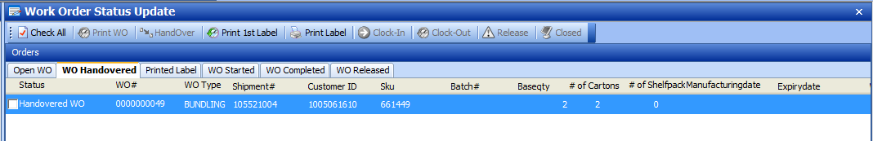

Output Label:

[Print 1st Label] - 1 set of bundle label (1 copy of each)

[Print Label] – 3 set of bundle labels (3 copies of each)

1. Pallet label

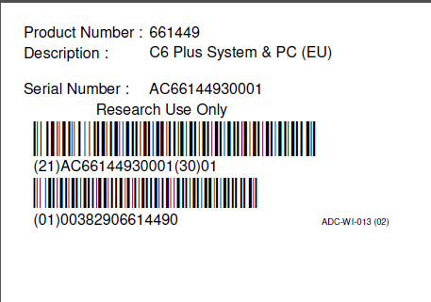

1. Cartons labels

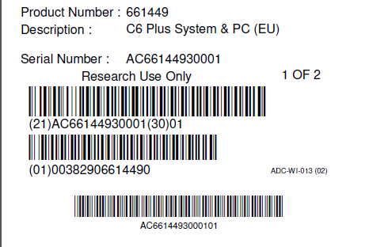

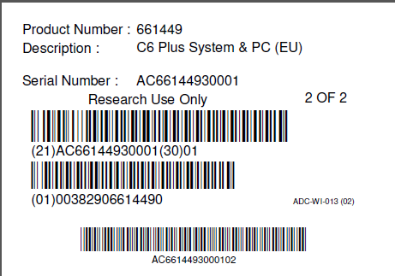

Re-print Pallet Label:

Choose “Carton ID” = 00 for re-print pallet label.

